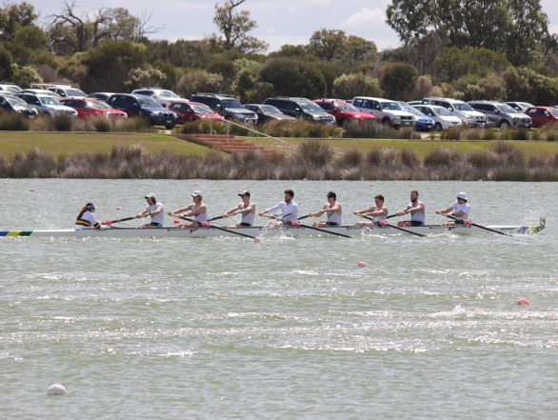
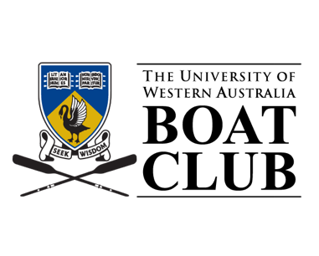

ANNUAL REPORT

2020-21
TABLE OF CONTENTS
Bronwyn Cox: 2021 Olympian from UWABC 1
Acknowledgement of Support 2
2021: The Long Awaited Olympic Year 3
Office Bearers 2020-21 5
Board Members 5
Committee Members 5
Strong Results for New Members 6
Increased Members After COVID 8
2021 Award Winners 10
Current Members 13
Club History 15
Captains 15
Club Oarsmen of the Year 16
Club Oarswomen of the Year 16
Life Members 17
Equipment 18

Bronwyn Cox: 2021 Olympian from UWABC

Bronwyn Cox was selected in the Australian Women’s 8 for the 2020 Tokyo Olympics. With the unfortunate onset of COVID-19, the National Training Centre in Penrith, NSW was closed, and the Olympics delayed to 2021.

Bronnie moved back to Perth for a rejuvenating 12 weeks with family and friends before returning to Penrith and continuing her training into the 2021 Olympics.

With an extensive training program including time spent simulating the hot and humid Japanese climate in steam tents, Bronnie was well prepared for her Olympic aspirations.

After a heat with the USA and Romania on the first day, Bronnie’s crew overcame Great Britain in the day 5 repechage to qualify for the A-final. By day 7, the women were well rested and came fifth in the A-final in front of previous challengers Romania. The gold medal was claimed by Canada.

Throughout her training and Olympic campaign, Bronnie has been an incredible role model and inspiration for all UWABC members. We wish her all the very best for the 2024 Paris campaign.

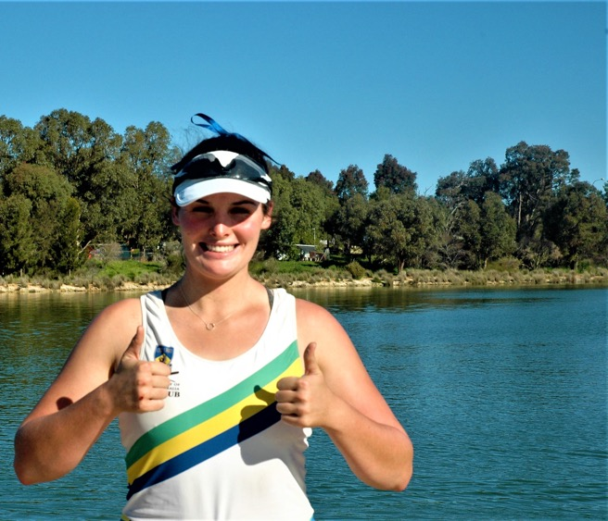

Acknowledgement of Support

This year the Boat Club completed its second year of fundraising toward out five-year target of $1M. With over $834,000 already received in pledges and donations, we are well on our way to ensuring that every person who wants to row has the equipment and the chance to do so.
We welcome all contributions to the Future Fund:
uwarowing.org.au/donate

Thanks to the pledges and donations of our generous alumni, the Boat Club purchased a men’s coxed eight in 2021. We are extremely grateful to former state team rower and ABC journalist Miriam Borthwick who interviewed John Inverarity after whom the boat was christened. John was a former Australian cricket team member and selector, Headmaster of Hale School, and is currently Chair of UWA Sports Advisory Council.

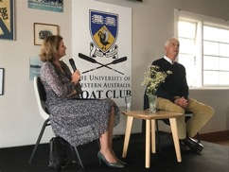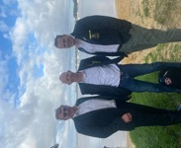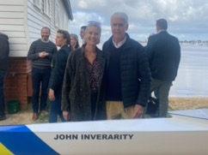

During the interview, John eloquently spoke of the value of sport for university students and the unique attributes of athletes who train, study, and ultimately compete together through the UWA Boat Club. He observed that we provide a crucial experience to UWA students and are a key reason that modern students participate in on-campus activities.

As part of the advisory council, John continues to be a champion of sport and the Boat Club within UWA. Over 50 current members and alumni attended the boat christening together with UWA Sport staff and the Inverarity family. The boat christening was expertly organised by Karlie Payne, Vice President of Alumni Relations.

2021: The Long Awaited Olympic Year
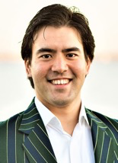
UWA Boat Club is back and on the world stage.

Olympics: Tokyo 2021
Olympian and Club member Bronwyn Cox was selected in the Australian Women’s Eight. Due to the COVID-19 pandemic, all national and international events were cancelled, including the 2020 Tokyo Olympics. She continued her training into 2021 and qualified for the Olympic A-final. Bronwyn and the Australian Women’s Eight came fifth in the final and have done Australia proud. She returned to our Club in September 2021 and competed at the WA State Championships with our open women’s squad.

Club Awards
At the time of writing, Rowing WA has not yet awarded the end of year awards.

Strategic Plan 2021-2026
UWABC Board member Megan Bagworth has consulted with all members through a written survey and in-person workshop to determine the values of the Club’s members. The Committee and Board have returned a strategic plan for the next five years that aims to improve member outcomes across all levels and improve attraction and retention of our members.

Welcome to our new High-Performance Coach
The Club thanks its high-performance coach Ethan Aird for coaching over the 2020-21 nationals season and welcomes its new high-performance coach George White for the 2021-22 season. George has been an excellent coordinator of the Shenton College Rowing Program and we look forward to his building rowing experience.

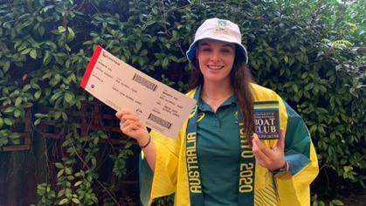
Figure 1: Bronwyn Cox - UWABC Olympian in 2021

Forrest Hall
The construction of the second Forrest Hall building has continued in 2021. The Boat Club has been assured uninterrupted boat trailer access to the Boat Shed for transporting equipment to and from regattas during construction and upon completion. The University is currently undertaking a process to construct a new boat ramp from the concrete apron to the water’s edge. Finally, a dive report in late 2019 identified structural defects in the pontoon and replacement of the substructure was approved in February 2020. Progress has been made with the tender process for the pontoon substructure and the construction of the boat ramp.

Fundraising for Mental Health Awareness and Shenton College Rowing
Congratulations to George White and the Shenton College Rowing Program for organising a mental health appeal in Term 1 2021. A 24-hour ergathon was held at the school which raised over $3,660 for mental health awareness. Most donations were from the Shenton community and was an excellent promotion of our rowing culture and led to student recruitment at the commencement of the school year. This is an excellent follow up to the 2020 appeal in support of the NSW bush fire appeal that raised over $3,500.

Pararowing
Dayne Metzner ran a successful para-rowing initiative at UWA Boat Club in 2021. 14 people used the ergometers and single sculls widening the impact of rowing in the community. Rowing WA provided floatation aids that were critical to the safety of the program. The participants had an excellent time and were able to participate in sport in the wider community.

Congratulations and thanks
We congratulate Teresa Belcher, one of our Masters’ Women who has recently been qualified as a Boat Race Official. We also thank Michael Hawkins, who was one of the Boat Race Officials who adjudicate our regattas. Without the tireless efforts of all our Boat Race Officials, we could not compete in regattas. Our Club is proud of our members volunteering for the betterment of rowing in the community.

Finally, UWABC would like to congratulate and thank Craig James OAM on 50 years of service to the rowing community. Decades of competitors, officials, and administrators joined together across Australia to thank Craig for his service. Craig reminisced on his time at UWABC fondly and we look forward to many more years with Craig on our Board.

Jeremy Gillbanks
President

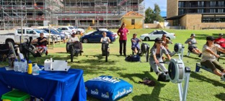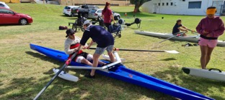

Office Bearers 2020-21

Board Members
Name | Elected | Term Expiry
Garth Lucas | 2018 | 2021
Jacinta Scanlon | 2018 | 2021
Robert Hepburn | 2018 | 2021
Craig James OAM | 2019 | 2022
Sara Peet | 2019 | 2022
Megan Bagworth | 2019 | 2022
Timothy Widdicombe | 2019 | 2022
David Bean | 2020 | 2023
Gavin Rezos | 2020 | 2023

Committee Members
Name | Position
President | Jeremy Gillbanks
Vice President – Alumni Relations | Karlie Payne
Vice President – High Performance | Fraser Pensini
Captain | Sophie Rowe
Secretary/Director of Administration | Tessa Bevilacqua
Assistant Secretary | Hannah Page
Men's Vice Captain | Angus Rowe
Women's Vice Captain & Sports Student Council Rep. | Isabella Emery
Treasurer | Christopher Morley
Registrar | Sarah Knight
Boat Officer | Harrison Cooke
Safety/Ramp Officer | Kelvin Fewings
Social Secretary | Lucy Eadon
Shenton Co-ordinator | George White
General Committee Member (formerly Novice Representatives) | Oliver Hoare & Portia Knight
Fundraising Officer | Lara Glendinning
Patron | Gavin Rezos
Vice-Patron | Alan Robson

Strong Results for New Members

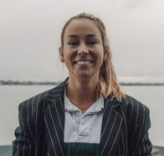
State Championships
Congratulations to all members who competed in all state championship events this season. We came away from the 3 regattas with 15 state championship titles and multiple podium finishes.

All Schools State Championships
Across all year groups Shenton College had some great results with many podium finishes. Well done to all the students for their hard work and dedication to training throughout this year and their shortened season. Massive thank you and compliments to the coaches who dedicated their time to the All-Schools season for 2021. Shenton College came away with an overall total of 10 medals with 3 of those being gold:
- Y10 Girls Coxed Quad | - Y10 Girls Coxed Eight | - Y10 Boys Coxed Quad

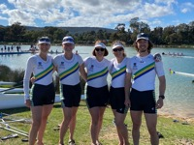
Masters State Championships
With a significantly shortened season and the State Championship regatta in May this year the masters athletes had a successful season across all regattas. With larger numbers in both squads, we had athletes racing in all boat classes. Congratulations to the strong group of masters athletes we had this season with an overall total of 13 medals and 5 state championships:
- Masters Women’s E-M Grade Coxed Quad  - Masters Women’s E Grade Double Scull | - Masters Men’s Coxless Four  - Masters Men’s Coxed Eight | - Masters Women’s F-M Grade Double Scull

Thank you to Angus Rowe for dedicating your time coaching the masters women’s squad this season.

Pennant State Championships
The state championship weekend was hugely successful for all UWABC athletes. We had athletes from all squads competing across all grades including A,B, C, Novice and Masters. Thank you to all coaches for preparing all the athletes to compete at their best over the championships. We had 23 overall podium finishes and a total of 7 state championships:
- Women’s B Grade Coxless Quad  - Men’s C Grade Coxed Four | - Men’s C Grade Single Scull  - Women’s C Grade Coxless Pair | - Men’s Novice Coxed Four  - Men’s Novice Coxed Quad  - Women’s Novice Coxed Four

Bunbury Regatta
This year UWABC competed at two regattas in Bunbury. The first was an unofficial regatta with Curtin University Boat Club and Bunbury Rowing Club. We had a large attendance at this regatta with representation in all grades and races on the day. The second Bunbury regatta was the Bunbury Sprint Championships with UWABC competing in all races and winning 6 sprint championship titles.

UniSport Nationals 2021 (formerly Intervarsity, University Games)
Unfortunately, due to COVID-19 outbreaks over on the east coast during the year, the intervarsity competition was not held in 2021.

Nationals 2020
The 2020 nationals squad trained consistently over the summer period preparing for competition at Lake Barrington in Tasmania. Due to the evolving situation of the COVID-19 all West Australian coaches discussed and decided that a smaller squad would be sent to compete. Congratulations to all athletes who trained over the summer and especially to William Hynes, Clare Netherway, Thea Adamson and Bronwyn Cox who represented UWABC at the regatta. Massive thank you and congratulations to Ethan Aird for coaching the squad over the national’s season.
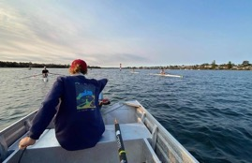
UWABC was represented in multiple state crews. Congratulations to our athletes who were selected:

King’s Cup: Maximillian Montanari
Queen’s Cup: Bronwyn Cox and Clare Netherway
Men’s Youth 8: Ethan Aird (co-coach)
Women’s Youth 8: Clare Netherway
Neil Slater Cup: Thea Adamson, Ethan Aird (co-coach)

Volunteer Coaches
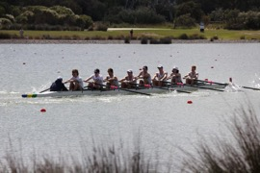
This season we had a total of 13 volunteer coaches across five squads. All squads displayed significant improvements and development throughout the season showed through the results achieved at State Championships. Also, thank you to the 16 Shenton coaches who also volunteered their time over the season.

Equipment
Mid way through this season we christened a second hand eight the John Inverarity. This boat has come into be used as the second top men’s eight and will be used throughout the shed for many years to come.

Sophie Rowe
Captain

Increased Members After COVID
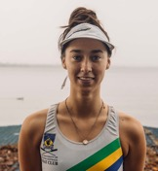
This year has been an exciting year with new social events, more opportunity for fundraising, the Tokyo 2020 Olympics, and occasional COVID-19 scares! With the lockdown and restrictions from 2020 easing, this year was aimed at reclaiming freedom and making up for lost time. New friends were made, medals were won, and social events were attended. All with the UWABC sprit we all know and love.

Fundraising and Community Engagement: Many Hands Make Light Work
Lara Glendinning did an amazing job this year as fundraising captain. Major club revenue came from the coordination, organisation and dedicated volunteers over the seasons fundraising events in the effort to upgrade our fleet and equipment. It is clear our UWABC members are passionate, engaged, and have supported the club by volunteering their time, donating to hosted regattas and facilitating fundraising events.

We partnered with Cockburn Ice Area at the commencement of the school year to integrate our Shenton members with our club squads. Lara, with the help of Jonathon Jaschke, designed and sold limited-edition UWABC bucket hats that were in high demand from both alumni and current members.

The Clean-Up-Australia Day project was continued along the Matilda Bay Foreshore and collected over 6 bags of rubbish with the help from members, UWA residential college students, and members of the community. Our Containers for Change was a way to prevent further pollution to our bank and promote the recycling of bottles and cans from our social events whilst receiving a small revenue.
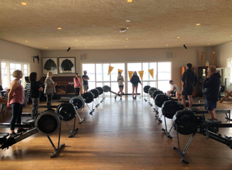
The Club hosted both Masters and All-Schools regattas and were able to raise over $2,000. This was due to the generosity of members and family who donated food, coffee, time, and raffle prizes for both events.
Figure 2: Ergo classes targeted inactive adults to improve the wellbeing of our community.

In celebration of the Tokyo Olympics, the Club hosted a morning tea at Rowing WA Headquarters where Lara Glendinning organised a breakfast for people to enjoy while watching UWABC member Bronwyn Cox compete in the Australian Women’s Coxed 8. UWABC members volunteered their efforts to the successful event and the event was featured on channel 7’s Olympic coverage.

Ergo classes aimed at targeting inactive members of the community was a huge success bringing in over $900 for the club and more classes are planned for 2021-22. The Learn 2 Row group this year was coordinated by Sarah Knight and received high interest with many participants choosing to continue rowing and join the Club.

Our continued sponsorship by Broadway Eatery allows the club to support small, local businesses and in turn foster UWABC sense of community after training every morning.

Staying Safe This Season: Prevention Over Reaction
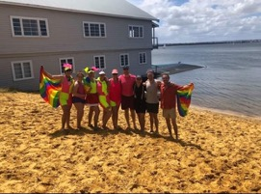
COVID safety procedures were kept in place throughout the year as well as updating our safety standards to ensure the protection of all members on and off the water. Beginning with a safety induction at the start of the season, our Safety Officer Kelvin Fewings increased mental health awareness amongst the members, devised a risk management matrix and utilised his 3D printer by making holders for ventilator and space blanket in all our dinghies. Club Registrar Sarah Knight created a river safety quiz and updated the terms of membership upon sign-up to include further safety provisions. Given the change to the WA Department of Transport rules, flashing lights will be applied to the dinghies next year as per the new Rowing WA rules.

Social Calendar: Making Lasting Memories
This year we were able to add new social events to the calendar as COVID-19 restrictions eased from last year. Lucy Eadon started off the social year with a successful Pride Brunch to support LGBTQIA2S+ and pride week. It was great to see so many club members, friends and family down enjoying our view of the river whilst celebrating inclusivity within our club and broader communities.

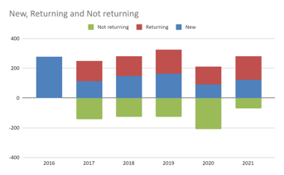
Our newcomers enjoyed social events throughout the season to enhance their student experience. They made new friends from the first day of rowing with our season opener, two Bunbury regattas, and celebration of state and national championships. The UWA student experience continues to be a pillar of our Club.
Figure 3: Pride Row and Brunch during Pride Week.

Membership
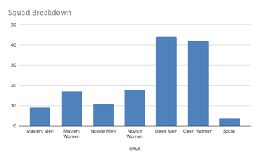
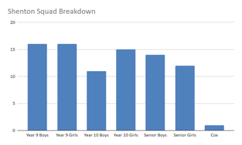
Membership increased by 48% to a total of 313 from 211 last year and a further increase from 2019 membership numbers. Both open squads returned to pre-COVID numbers and the Shenton College Rowing Program contributed over half of the overall membership numbers.

Tessa Bevilacqua
Director of Administration

2021 Award Winners
The University of Western Australia Boat Club is pleased to present the following people with their awards for the 2020-21 rowing season.
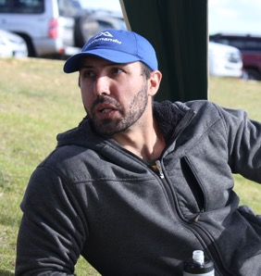  Oarsman of the Year  Grant Adendorff | 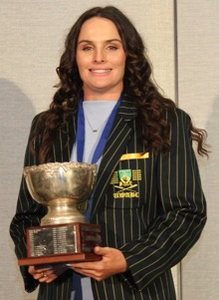  Oarswoman of the Year  Bronwyn Cox
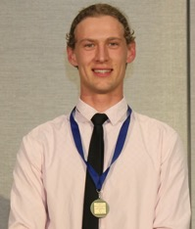  Most Improved Male of the Year  Dayne Metzner | 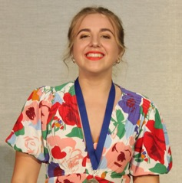  Most Improved Female of the Year  Isabella Marchetti
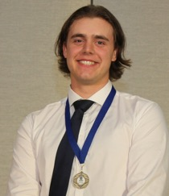  Best First Year Male of the Year  Isaac Hamilton | 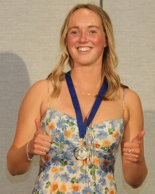  Best First Year Female of the Year  Pippa Joyce
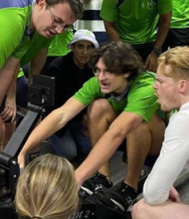  Novice Man of the Year  Matthaus Zering | 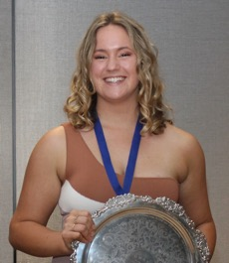  Novice Woman of the Year  Evelyn Younge
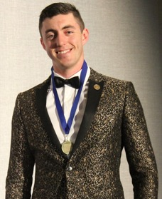  Club Service of the Year  William Hynes | 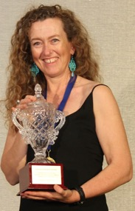  Club Points Champion of the Year  Orla Flecker

Current Members
We value our whole UWA Boat Club community. Below is a list of our members in 2021.
Abigail Burbridge | Ben Rosser | Courtney Hanlon | Emma Herring | Harrison Cooke
Adam Feilding | Bethan Rainey | Craig James OAM | Emma Secombe | Hayley Rowe
Adèle Leahy | Bethany Hunt | Daisy Webster | Esther Cooney | Heather Bytheway
Ahren Den Ouden | Bianca Fewings | Damien Kelly | Ethan Aird | Holly Younge
Alex Harrison | Bill Burbidge | Daniel Bruce | Ethan Bromley | Innes Raeburn
Alex Ulbrich | Blake Hillier | Daniel Chiang | Eva Czislowski | Isaac Hamilton
Alex Weedon | Bonnie Tse | Daniel Clarke | Eva Huggins | Isabela Douglas Pina
Alexander Celenza | Bridget Uren | Daniel Holding | Eve Duncan | Isabella (Izzy) Emery
Alexander Edis | Brittany Crawford | Daniel Mowe | Evelyn Bowen | Isabella Marchetti
Alexander van Hoek | Bronte Baxter | David Bean | Evie Gan | Isabelle Warpenius
Alice Gralton | Bronwyn Cox | David Beros | Evie Younge | Izzy Ercleve
Alice Millichip | Bruce Faulkner | David Porzig | Finlay Pyke | Izzy Wilkes
Alice Ryall | Caitlin Smith | David Wittber | Finn Melville | Jacob (Jake) Sangster
Alistair Cadee | Cameron Van Zwam | David Young | Frederick Edwards | James Heptinstall
Amelia Darvall | Carolyn Smith | Dayne Metzner | Garth Lucas | James Paton
Amelie Sampson | Celia Cornwell | Dianna Matius | Gemma Havorcroft | James Waterhouse
Amy Boulazeris | Chaeleen Lagnada | Domenico Malavisi | George Nicholson | Jamie Cairns
Andrew Brown | Charles Worthington-O'Leary | Doughal MacMaster | George White | Jana Peralta Garcia
Andrew Lewin | Charlie Newnham | Duncan Barton | Georgia Oakley | Jaslyn Sidhu
Angelica Martino | Charlie Rodan | Dylan Foppa | Georgina Fisher | Jeremy Gillbanks
Angus Rowe | Charlotte Davies | Ella Tooby | Grace Douglas | Jessica Williams
Angus Treloar | Cherie Stokic | Elliot Kluken | Grace Dumas | Jessie McKay
Aoibheann Dhepnorrarat | Chloe Michael | Emerson Williams | Grace Foley | Jet Ryan
Arya Pandey | Chris Morley | Emily Hoare | Grace Gibson | Joanna Edgar
Asra Khan | Claire Rogers | Emily Lowe | Grant Adendorff | Joe Caspersz-Loney
Ava Fitzgerald | Clare Netherway | Emily Tuckey | Guy Rosser | John Hugo
Avril Sanderson | Connor Brace | Emily Woodward | Hannah Malcolm | Jonathan Jaschke
Bailey Ireland | Cooper Anspach | Emily Woodward | Hannah Orchard | Jorden Desmond
Bella Pettingill | Cooper Winstanley | Emma Cross | Hannah Page | Joseph Blake

Current Members
Joshua Spencer | Maddie Baxter | Oliver Hoare | Sarah Knight | Tom Newton
Kaleb Jaschke | Maddy McLauchlan | Olivia Park | Sarah Major | Tom Warner
Karega Gibbs | Maisy Poole | Olivia Stone | Savannah Clee | Tom Wilson
Karl Meyer-Rodenbeck | Majella Warpenius | Olivia-Rose Macdonald | Sean Day-Barnes | Toni Tuxworth
Karlie Payne | Makisha Smith | Orla Flecker | Seb Forsyth | Tyson Landers
Kaylia Brennan | Margaret Bowen | Oscar Revelins | Sedrick Dongsal | Vicky Sun
Keith Reynolds | Mario Fonda | Oscar Sampson | Sharna Lambert | Vivienne Noonan
Kelvin Fewings | Mason Sullivan | Patrick Walsh | Shayan Rasaratnam | Warren Gibson
Kiara Davis | Matthaus Zering | Pippa Joyce | Sian Tuxworth | William Hart
Kieran Reading | Matthew Callaghan | Pippa Sanderson | Sienna Tolomei | William Hirst
Kiki Williams | Matthew Poon | Poppy Knapton-Lonsdale | Simon Tomlinson | William Hynes
Kye Binyon | Matthew Randall | Portia Knight | Sofia Bevilaqua | William Walker
Lachlan Richardson | Max Ludwig | Qiyu(Ryan) Xu | Sophia Kirkaldy | Xanadu Jaworska
Lara Glendinning | Max Montanari | Rachel Collins | Sophie Davison | Yannik Simkovics
Lauren Halvorson | Maxim Strizek | Rhys Symonds | Sophie Foster | Zen Vakil
Lauren James | Megan Bateman | Richard Thomas | Sophie Rowe | Zoe Batt
Leo Mondain | Mia Williams | Riley Duncan | Sophie Secombe | Zoe Hughes
Liam Guiney | Michael Hawkins | Robert Lea | Stephanie Carcenac
Liam Nguyen | Michael Millar | Robert Rowell | Tamsin Keevill
Lily Bree | Morgan Armstrong | Robert Seres | Taylor Laramee-Jupp
Liz Warrand | Naomi Taylor | Rosie McAuliffe | Tess Kirkaldy
Logan Tootell | Natalie Trang | Ruth Dogovski | Tessa Bevilacqua
Lucas Roosendaal | Natasha Long | Sagar Badve | Thea Adamson
Lucy Barr | Ned Cooney | Sam Hart | Theodora Raptakis
Lucy Eadon | Niah Panton | Sam Pettingill | Thomas Power
Luis Alviarez | Nick Weedon | Sam Stirling | Thomas Sweeny
Luke Forsyth | Nikki Newton | Sam Whitby | Timothy Widdecombe
Luke Schortinghuis | Oleg Pakhotin | Samuel Jaschke | Todd Melville
Lynne Mannolini | Oliver Cliff | Samuel Wride | Tom Lymburn

Club History

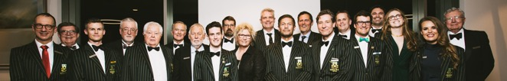
Captains
Name | Year |  | Name | Year
S.E.M. Rowe | 2020-2021 |  | R.M. Rowell | 1967, 1969
M.O. Montanari | 2019 |  | G.M. Rintoul | 1968
H.E. Child | 2017-2018 |  | M.P. Bond | 1966
K.B. Payne | 2013-2016 |  | B.R. Martin | 1965
T.L.T. Cunningham | 2011-2012 |  | D. McKee | 1964
G.W. Lucas | 2007-2010 |  | J. Ryan | 1963
R.F. Anderson | 2005-2006 |  | W.R. Burbidge | 1961-1962
A.R. Feilding | 2003-2004 |  | A.E. Bird | 1960
S. O’Conner Smith | 2002 |  | J.C. Hanrahan | 1959
K.I. Binks | 2001 |  | R.E.S. Argyle | 1957-1958
R. Adams | 2000 |  | J. Collis-Bird | 1956
B. Rummins | 1999 |  | C.N. Cuthbert | 1955
D.P. Barton | 1996-1998 |  | E.N. Maslen | 1954
K. Reynolds | 1991-1992, 1994-1996 |  | R. Kernot | 1953
T.I. Omari | 1993 |  | I.W. Morrison | 1952
C. Edwards | 1989-1990 |  | J.H. Rogers | 1951
P.S. Walsh | 1988 |  | B.W.S. James | 1950
G.J. Rezos | 1987 |  | P.B. Lowe | 1949
D.W. Barber | 1986 |  | J.L. Paton | 1948
M. Sloss | 1985 |  | R.J. Mofflin | 1947
J.S. Throssell | 1982, 1984 |  | C.M. McWhae | 1946
P. Bowen | 1983 |  | N.Q. Towie | 1944-1945
R. Coakley | 1981 |  | A.L. Arcus | 1943
J.J. Hobbs | 1979-1980 |  | H.R. Nash | 1942
I.P. Clairs | 1977-1978 |  | D. Barratt-Hill | 1939-1941
C.A. Richards | 1977 |  | T.H. Roberts | 1933
D.A. Bean | 1976 |  | C. Sanders | 1931-1932
C.H. James | 1974-1975 |  | O.F. Fry | 1930
W.J. Gibson | 1971-1973 |  | H.V. Reilly | 1928-1929
P.J. Emory | 1971 |  | F.A. Williams | 1922-1924, 1926-1927
D.J. Pickett, J.B. Abbott | 1970

Club Oarsmen of the Year
Name | Years |  | Name | Years
F.A. Pensini | 2019-2020 |  | J.S. Throssell | 1985
J.S. Kerr | 2016-2018 |  | E.P. Rovira | 1984
T.E. Widdicombe | 2010-2015 |  | W.J. Witham | 1983
P.J. Franks | 2009 |  | I.P. Clairs | 1982
M.J. Poole | 2007-2008 |  | J. Burt | 1981
R.J. Alderman | 2006 |  | R. Coakley | 1980
D. Dennis | 2000-2004 |  | P.F. Duckett | 1979
S. Berridge | 1998 |  | J. McGrath | 1978
A.T. Argyle | 1997 |  | S. Donaldson | 1977
M.J. Puls | 1996 |  | M.E. Sasse | 1976
S. O’Conner Smith | 1994-1995 |  | C.H. Curry | 1974-1975
S. Powell | 1993 |  | J.R. Howard | 1973
I. Clarke | 1989, 1991-1992 |  | G.R. Ward | 1972
T. Warner | 1990 |  | R.W. Cooper | 1971
W. Hutton | 1988-1989 |  | R.N. Le Souef | 1970
D.P. Kennedy | 1987-1988 |  | J.L.H. Formby | 1967, 1969
P.S. Walsh | 1986 |  | G.M. Rintoul | 1968

Club Oarswomen of the Year
Name | Years |  | Name | Years
B. Cox | 2016-2020 |  | Y. Barrett | 1995
M. Simmonds | 2011-2015 |  | S. Peacock | 1993-1994
G. Baker | 2010 |  | C. Graston | 1990-1992
E. Alderman | 2009 |  | L. Langmead | 1988-1989
M. Bagworth | 2008 |  | C. Pidgeon | 1987
E. Alderman, E.Rose | 2007 |  | A. Arndt | 1986
J. Huston | 2003, 2005-2006 |  | R. Walker | 1985
G. Barter | 2004 |  | A. Maidment | 1984
R. Doyle | 2002 |  | R. Richardson | 1983
M. Campbell | 1996 |  | K. Dixon | 1975
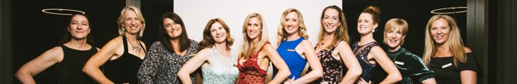

Life Members

Life members are elected by a majority of the voting members at an Annual General Meeting. They are outstanding individuals who have significantly contributed to the Club over many years. The Club would not be the same without the time and effort of the following people.

Name | Year Inducted
K.B. Payne | 2018
A.R. Feilding | 2018
D.A. Bean | 2016
A.C. Monger | 2016
G.W. Lucas | 2012
D.M. Werner | 2007
Dr. D.P. Barton | 2003
D. Wittber | 2002
J.L. Paton | 1998
K. Reynolds | 1998
C.H. James | 1996
R.M. Rowell | 1986
W.J. Gibson | 1986
K.D. Grant | 1984
Dr. J.H. Reynolds | 1973
D. McKee | 1964
R.T. Gard | 1963
W.R. Burbridge | 1962
DR. H.R. Nash | 1954
H.V. Reilly | 1954
A.L. Arcus | 1944
G. Barratt-Hill | 1941
W.A. Goland | 1939

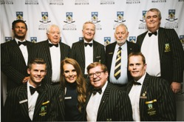
Figure 4: Life Members at the Centenary Dinner in 2019.
Back row, left to right: Keith Reynolds, Robert Rowell, David Bean, William (Bill) Burbidge, and David Wittber.
Front row, left to right: Adam Feilding, Karlie Payne, Craig James OAM, and Garth Lucas.

Equipment
During the 2021 season we christened the John Inverarity into our fleet. This boat has been well used by all squads throughout the season. This year we have retired the Graeme Rixon after 22 years of service, the R.T. Luke after 25 years of service, the Hill after 25 years of service, the Michael Morgan after 21 years of service, the David Wittber after 25 years of service, and the Rob Hepburn after 22 years of service.

Below is an extract of our major rowing equipment as at 30 September 2021 and rated Great, Good, Fair, Poor, or N/A (for wooden boats kept for historical purposes). Over the coming years we aim to turnover our fleet so that all members can learn to row and race with competitive equipment. We intend our next purchase to be a men’s coxed eight.

Boat Name | Make | Age | Condition
Eights
Robert Rowell | 2008 Sykes Eight | 13 years | Great
Don Werner | 2002 Vespoli Eight | 19 years | Good
John Inverarity | 2003 Sykes Eight | 18 years | Good
Craig James | 2000 Sykes Eight | 21 years | Fair
Keith Reynolds | 2000 KIRS Eight | 21 years | Fair
Cath Chandler | 1997 Sykes Eight | 23 years | Fair
David Bean | Ausrowtec Eight | 25+ years | Fair
Friends of UWABC | Sykes Eight | 25+ years | N/A
Coxed Four/Quads
Michael Morgan | 2021 Sykes Coxed Quad | New | Great
Gavin Bunning | 2013 Sykes Coxed Four/Quad | 8 years | Great
Rory Argyle | 2009 Sykes Coxed Four/Quad | 12 years | Good
Spirit of Shenton College | 2005 Johnson Racing Coxed Quad | 16 years | Poor
Roland Warren | 2002 Sykes Coxed Quad | 19 years | Poor
Adam Feilding | 2000 Sykes Coxed Quad | 21 years | Poor
Brad Loftus | 2000 Sykes Coxed Four/Quad | 21 years | Poor
Kayne Binks | 2000 Sykes Coxed Four/Quad | 21 years | Poor
Stephanie Greenway | Sargent & Burton Four | 25+ years | N/A
J.H. Reynolds | Wooden Coxed/Coxless Four/Quad | 25+ years | N/A
Coxless Four/Quads
Jessica Huston | 2017 Sykes Coxless Four/Quad | 4 years | Great
Simon Lee | 2009 Sykes Coxless Four/Quad | 12 years | Great
David Dennis | 2005 Sykes Coxless Four/Quad | 16 years | Good
Keith Reynolds | 1997 Sykes Coxless Four/Quad | 24 years | Good
Lyz Philp | 1999 Sykes Coxless Quad | 22 years | Good
Coxless Pairs/Doubles
Gwenda & Steve Kennedy | 2019 Sykes Coxless Pair/Double | 2 year | Great
Rebecca Lucas | 2019 Sykes Coxless Pair/Double | 2 year | Great
Jim Paton | 2013 Wintech Pair/Double | 8 years | Great
Michael Glorie | 2013 Wintech Pair/Double | 8 years | Great
Gemma Barter | 2013 MQR Double/Double | 8 years | Great
Tim Philpot | 2013 MQR Double/Double | 8 years | Great
Paul Myler | 2012 Wintech Pair/Double | 9 years | Great
Duncan Barton | 2009 Swift Racing Double | 12 years | Fair
Prof. Alan Robson | 2004 Sykes Pair/Double | 17 years | Good
Ted Maslen | 1997 Sykes Pair/Double | 24 years | Poor
Reddaway | Wooden Pair/Double | 25+ years | N/A
Single Sculls
Fry | 2010 Johnson Racing Single Scull | 10 years | Poor
Glide Path | 2010 Johnson Racing Single Scull | 10 years | Poor
Sanders | 2010 Johnson Racing Single Scull | 10 years | Poor
Williams | 2010 Johnson Racing Single Scull | 10 years | Poor
Cohen | 2010 Swift Racing Single Scull | 10 years | Poor
Reilly | 2010 Swift Racing Single Scull | 10 years | Poor
Single and Ready to Mingle | 2010 Swift Racing Single Scull | 10 years | Poor
Worboys | 2010 Swift Racing Single Scull | 10 years | Poor
Penrhos | Single Scull | 11+ years | Poor
Scull 1 | 2002 Ted Hale Single Scull | 18 years | Poor
Scull 2 | 2002 Ted Hale Single Scull | 18 years | Poor
Scull 3 | KIRS Scull | 18+ years | Fair
Scull 4 | Ausrowtec Scull | 18+ years | Fair
Scull 5 | 2004 Sykes Scull | 17 years | Poor
Scull 6 | Wintech Scull | 5+ years | Good
Scull 7 | Howell | N/A | Poor
Scull 8 | Howell | N/A | Poor
Shenton 1 | MQR | N/A | Good
Shenton 2 | MQR | N/A | Good

